

Practices for Secure Software Report

Table of Contents
Document Revision History 3
Client 3
Instructions 3
Developer 4
1. Algorithm Cipher 4
2. Certificate Generation 4
3. Deploy Cipher 5
4. Secure Communications 5
5. Secondary Testing 5
6. Functional Testing 6
7. Summary 6
8. Industry Standard Best Practices 6

Document Revision History

Version | Date | Author | Comments
1.0 | 4/17/2026 | Ken Rasnake

Client



Instructions

Submit this completed practices for secure software report. Replace the bracketed text with the relevant information. You must document your process for writing secure communications and refactoring code that complies with software security testing protocols.

- Respond to the steps outlined below and include your findings.
- Respond using your own words. You may also choose to include images or supporting materials. If you include them, make certain to insert them in all the relevant locations in the document.
- Refer to the Project Two Guidelines and Rubric for more detailed instructions about each section of the template.

Developer

Ken Rasnake

Algorithm Cipher

For Artemis Financial I recommend that we go with AES-256 (Advanced Encryption Standard) for encryption and SHA-256 for hashing and checksum verification. AES is currently the standard for symmetric block encryption cipher that can be used to protect sensitive data. SHA-256 is a cryptographic hash function that is a great option due to it being highly trusted for integrity verification. This uses input data to create a fixed-length code that is used to verify integrity instead of recovering the original data. Both of these options are commonly used in financial and web applications due to being strong and modern options. Both recommendations are well supported in Java.
AES-256 uses a 256-bit key making key impractical for brute-force attacks to be used against it. SHA-256 creates a 256-bit hash value, hashing is one way making the original input unrealistic to be recreated from the digest. Good number generation that is random is vital to secure encryption. These random numbers are used for keys, initialization vectors, salts, and certificates. Where symmetric encryption uses one key that is shared like AES, asymmetric encryption uses public and private key pairs, like RSA.
With older algorithms, like DES, they are no longer considered secure due to the fact that their key sizes are too small with an effective key size of 56 bits. Triple DES made improvements in security with a key size of either double the DES keys or triple the DES keys; but both are now considered obsolete now as well. AES replaced the DES as the standard now to be considered modern. As for hashing, MD5 and SHA-1 are now considered to weak because of collision vulnerabilities. SHA-256 continues to be accepted widely and is part of the SHA-2 family used in systems that are secure now.

Certificate Generation

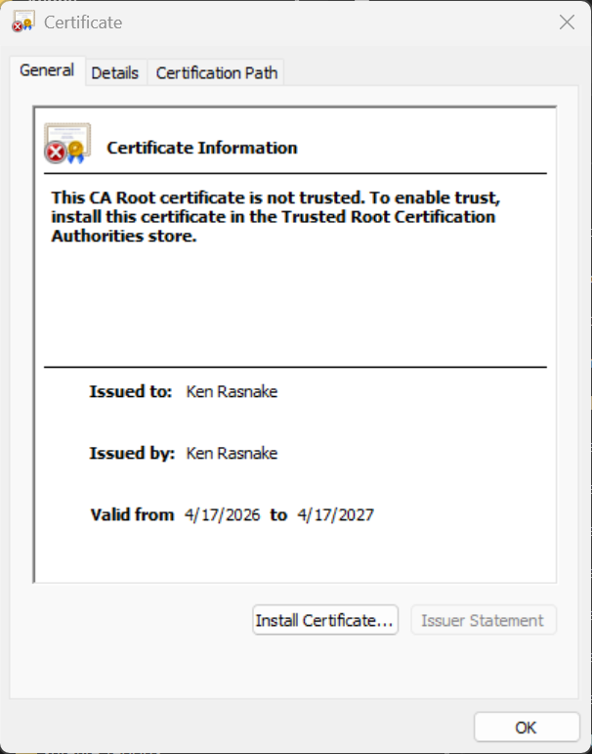

Deploy Cipher

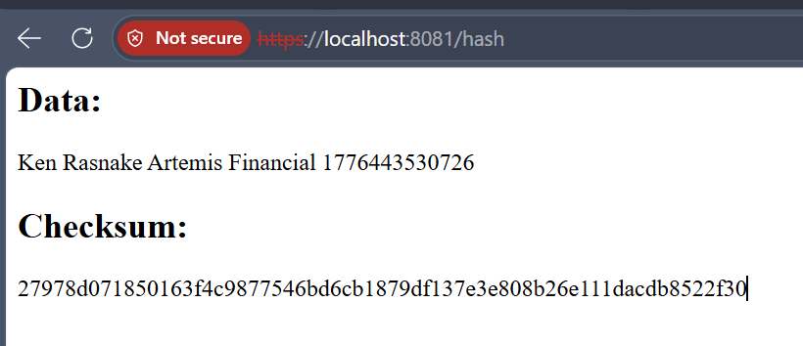

Secure Communications

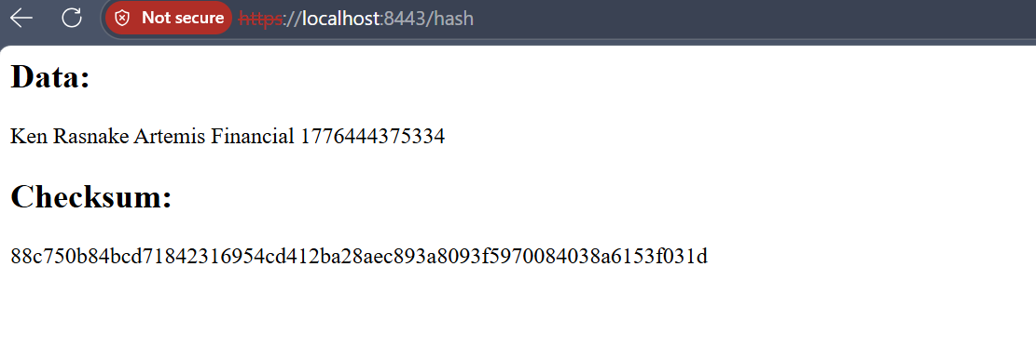

Secondary Testing

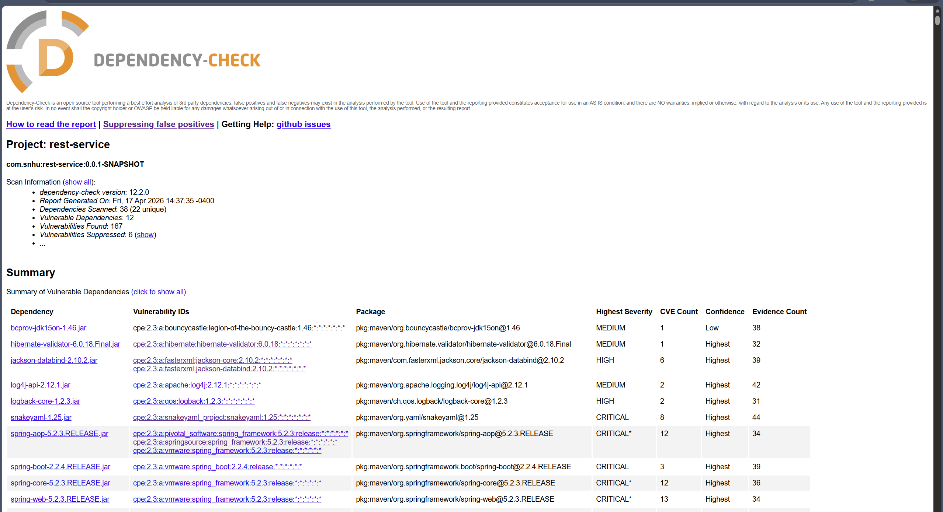

Functional Testing

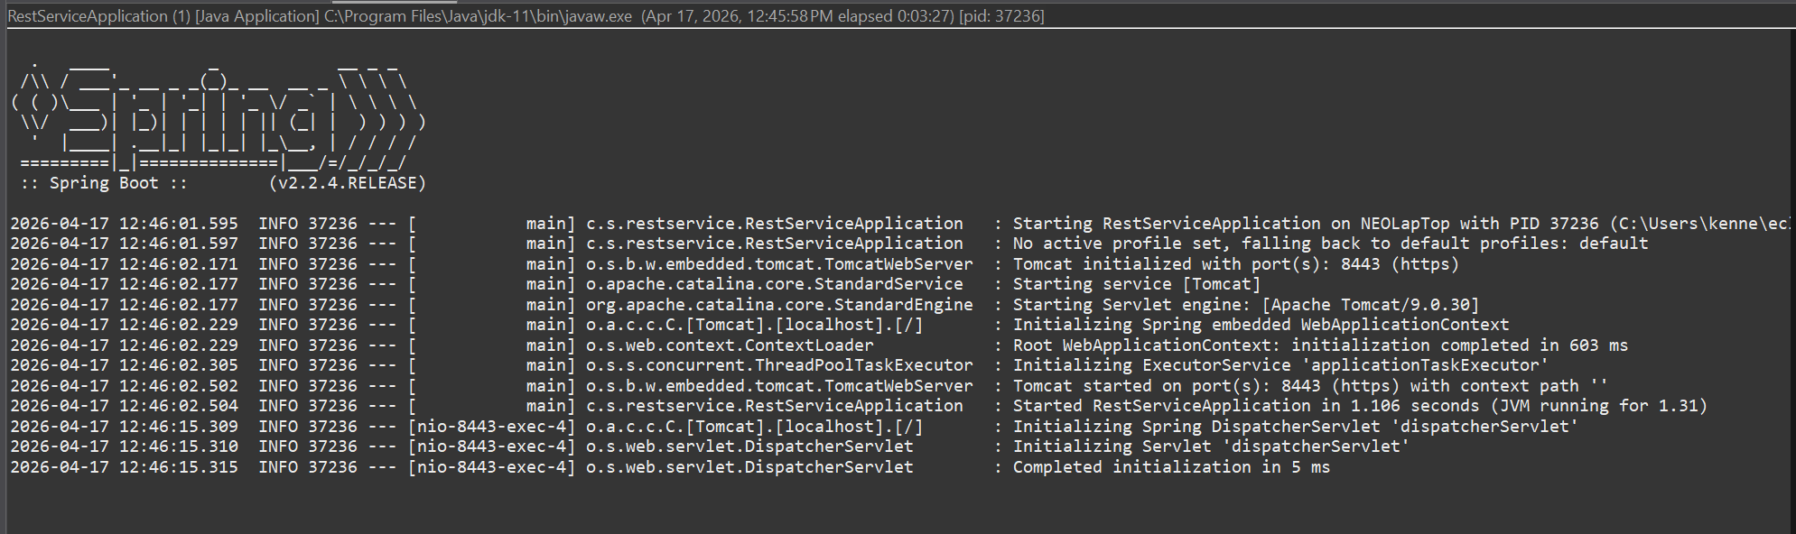

Summary

For the Artemis Financial application, I addressed several security vulnerabilities by using secure coding practices and improving the overall security of the system. I made the recommendation of using modern encryption standards, in this case using AES-256 to protect the data and using SHA-256 for integrity verification; both to ensure strong cryptographic security.

By generating a self-signed certificate using Java Keytool and configuring the application to use HTTPS making sure that the communication between the client and the server is secure. I also refactored the code to use the SHA-256 hashing algorithm we implemented a checksum to ensure integrity through hash endpoint. I also performed a secondary static test using the OWASP dependency-check tool to ensure that the refactored code did not cause any additional security risks. I also used suppression to address existing issues that were false positives. Using manual functional testing was also checked to make sure no issues on the logical, syntactical, or security issues, to make sure that the application ran correctly.

Throughout the project I was able to implement and demonstrate the importance of secure software development practices using encryption secure communications, vulnerability analysis, and testing to ensure that the program is reliable and secure.

Industry Standard Best Practices

I used industry standard best practices for secure coding while refactoring the code to maintain and improve the overall security of the Artemis Financial application. Several key practices were used, one being modern cryptographic standards that were strong. I used SHA-256 hashing for checksum verification to ensure data integrity and used AES-256 for secure encryption standard. Secure communication was also enforced by configuring the application to use HTTPS with a self-signed certificate. This helps to make sure that the data that is transmitted between the client and the server is encrypted.

I ensured that the application did not obtain new security risks by using trusted built in Java security libraries, reducing vulnerabilities that third-party components can have. I used static testing also using OWASP dependency-check tool to help identify vulnerabilities in the dependencies. I used suppression to handle false positives. Doing so helps to decrease the risk of adding additional security vulnerabilities with the changes.

Using industry standard best practices for secure coding can provide a great deal of security. Practices lie these can help to protect sensitive financial information, decrease chances for a security breach, and assist with protecting system reliability. Using secure encryption, using HTTPS, and validating dependencies, the application becomes less prone to data interception, tampering, and exploitation of known vulnerabilities.

